**Evan MacHale**

N00150552 / Year 4 Creative Computing

Requirements Document / 26th October 2018

3D Printing Generative Jewellery Web Application Utilising a Combination of 3D Subdivision and Data Structure Algorithms.

# DESIGN PROBLEM

Can I Use a Combination of 3D Subdivision and Data Structure Algorithms to create an interactive, generative playground/web store that allows users to create their own unique, computer generated jewellery, which may then be 3D printed?

# INTRODUCTION

## Background

The emergence of 3D printing has heralded a dramatic change in direction for industries like engineering, industrial design and even medicine. Using cheap materials, professionals can design, model and then print batches of components whilst being efficient, cheap and eco-friendly. They can used used in a variety of ways from prototyping engine parts, to modelling comfortable prosthetic limbs for patients. Yet 3D printing has limitations as to the size of the print at any one time and thus amplifies small projects further in the way described above.

But now too may the industry of jewellery manufacturing take advantage of this new technology. Instead of hand carving, casting and shaping jewellery, designers are now capable of utilising the power of computers to generate designs. Furthermore, with the recent emergence of *Generative Design* new technologies are being developed to enable designers to effortlessly amplify their work with algorithmic, computer generated designs.

## Rationale

Generative design is the concept that in the future, designers will no longer specify points, lines and surfaces when designing. Instead, they will specify abstract goals and constraints for their design and let computers specify the points, lines and surfaces; to algorithmically generate a design. There then occurs a dialogue between the designer and the computer to ultimately arrive at the design. These new technologies, led primarily by AutoDesk, are still in early development and not available to the public.

This project will develop a playground application that will allow users to explore new ideas and possibilities for jewellery using generative design.

The users will be able to choose a type of jewellery represented by a geometry and then apply algorithms to said geometry and generate unique and complex forms that would not nearly be achievable by means of traditional CAD programmes used in jewellery design.

This application will be built using the Three javascript library and will incorporate Catmull-Clark subdivision algorithms and Data Structures for generative design functionality.

# USER RESEARCH

## Interviews

The process of my preliminary user research involved interviews with three individuals who have been involved in the industry of jewellery, both in manufacturing or consumer retailing. These interviewees hold knowledge from around the industry and are themselves enthusiasts and collectors.

I would ask them the following questions:

1. Describe the decision making process you go through when browsing jewellery
2. What are your favourite types of jewellery?
3. Do you consider materials(and their price) that you prefer when choosing jewellery?
4. Do gemstones contribute to your decision making?
5. Would you consider the idea of 3D printed jewellery?
6. Would you consider yourself someone who enjoys to browse new releases of contemporary and unorthodox styles of jewellery (e.g Avant-Garde)?
7. Would you consider yourself someone who would enjoy creating their own jewellery?
8. What would be you reaction to an application that allowed you to generate your own Avant-Garde jewellery using the power of a computer and 3D printing; would you consider using it?

### 

### Interview One

My first user was Dympna Moran, a full-time mum, she has a number of years experience in high-street jewellery retailing and is someone who would consider herself an avid collector of jewellery fashion items.

*N.B. For reference see personas 'dympnaMoran.png' and ‘lornaONeill.png’ for background information.*

From the interview with Dympna, she spoke at length about the many factors that are at play when both choosing and selling jewellery, due to the nature of the industry. This industry of luxury and precious commodities makes the process rather slow, primarily due to pricing. Such a process **(1)** involves a very much back and forth process of trying and browsing to see what looks good and what the consumer believes looks the best personally, like all fashion; is it comfortable to wear, is the piece for everyday or on occasions? What is the background of the design or piece, does it have collectable value? Even the item itself, the clarity of the cut gems, the setting of the gem, the material of the metals (platinum, gold, silver, etc.) and then the weight, especially for bracelets or necklaces.

Dympna then spoke about **(2)** rings, her favourite jewellery pieces and why **(3)** materials are such a significant part of the process. With regards to jewellery there is always a budget. Naturally, the consumer would always want to get the best quality piece made and designed with the best quality of materials, but this comes at a price. Therefore the consumer is always willing to wait for the right time to buy the best product and capitalise on their purchase.

Furthermore, with rings Dympna reiterated that **(4)** gemstones are not the be all and end at for pieces. The designer, materials, subjective taste and price all play larger roles than the gems.

She then went onto explain that **(5)** 3D printing sounded interesting, that she would never dismiss new design approaches and contemporary ‘one of a kind’ pieces. Dympna regularly enjoys **(6)** browsing and reading about all kinds of jewellery, ranging from the antique to the contemporary.

With regards to **(7)** creating one’s own jewellery, Dympna said that she had always been interested due to her natural appreciation for jewellery but never would due to how creative and arduous a process it would be. Given the context of this research project, she further elaborated that **(8)** given that such a process was made fun and convenient she would most definitely be willing to explore such a concept.

### 

### Interview Two

My second interview was with Lorna O’Neill, who has a background in film and stage design and works for RTÉ. Lorna has worked part-time in crafts, her most loved hobby and eventually decided to make a side job out of it during her career. She has made and sold things at craft fairs ranging from cloth toy dolls to shaped jewellery.

From my interview with her, Lorna explained that when **(1)** looking for pieces of jewellery to wear, it is very much to do with pairing the jewellery to a particular look or outfit for her. Comfort is a big part for Lorna as well as what she described as quirkiness, how individual does the piece look?

Lorna told me that her favourite **(2)** pieces are small like necklaces, earrings and brooches. Comfortable texture **(3) (4)** in material and colour of gemstones, she explained were her must haves.

When asked about **(5)** 3D printed jewellery, she was extremely enthusiastic. Lorna explained that such an unusual way of creating jewellery was bound to have it’s own weird and unique styles that could be expanded and explored to produce elegant forms.

Lorna agreed **(6)** that she was someone who loved observing new and contemporary styles, yet said she wouldn’t necessarily investing in them due to price.

Of course, Lorna then agreed **(7)** that she loved creating all sorts of craft, including jewellery.

Lorna, lastly, thought **(8)** she would like to use such an application. She spoke about how the ability to design quickly, to re-scale, colour and test on the body cheaply would be very useful. 3D or even 2D patterns and design would be good fun she claimed.

## Conclusion

From the first four questions, it is clear that choices are made based off pairing pieces to a look or outfit, and that materials are very important for comfort. Moreover, that some aspects like gems may be re-considered or dropped due to price.

Price appears to be a large factor in this industry and cheap, high resolution 3D printed pieces are a potential alternative.

3D printing is a mixed bag as it is not widely available for personal use, yet enthusiasm for the idea is well voiced and recieved.

Such unusual styles, avant-garde and contemporary, such that only a computer could produce, are also well received and considered. Modern styles are prevalent as much as the most traditional. The fact that such styles could be produced so easily is a huge factor in its consideration as an application idea, expressed by the interviewees.

## Personas

## 

## 

## Paper Prototype

### Preliminary Prototype

From my research I set out putting pen to paper coming up with some sort of prototype layout.

I defined early on, from my personas, rough user needs for my application and a hierarchy for which to implement it with:

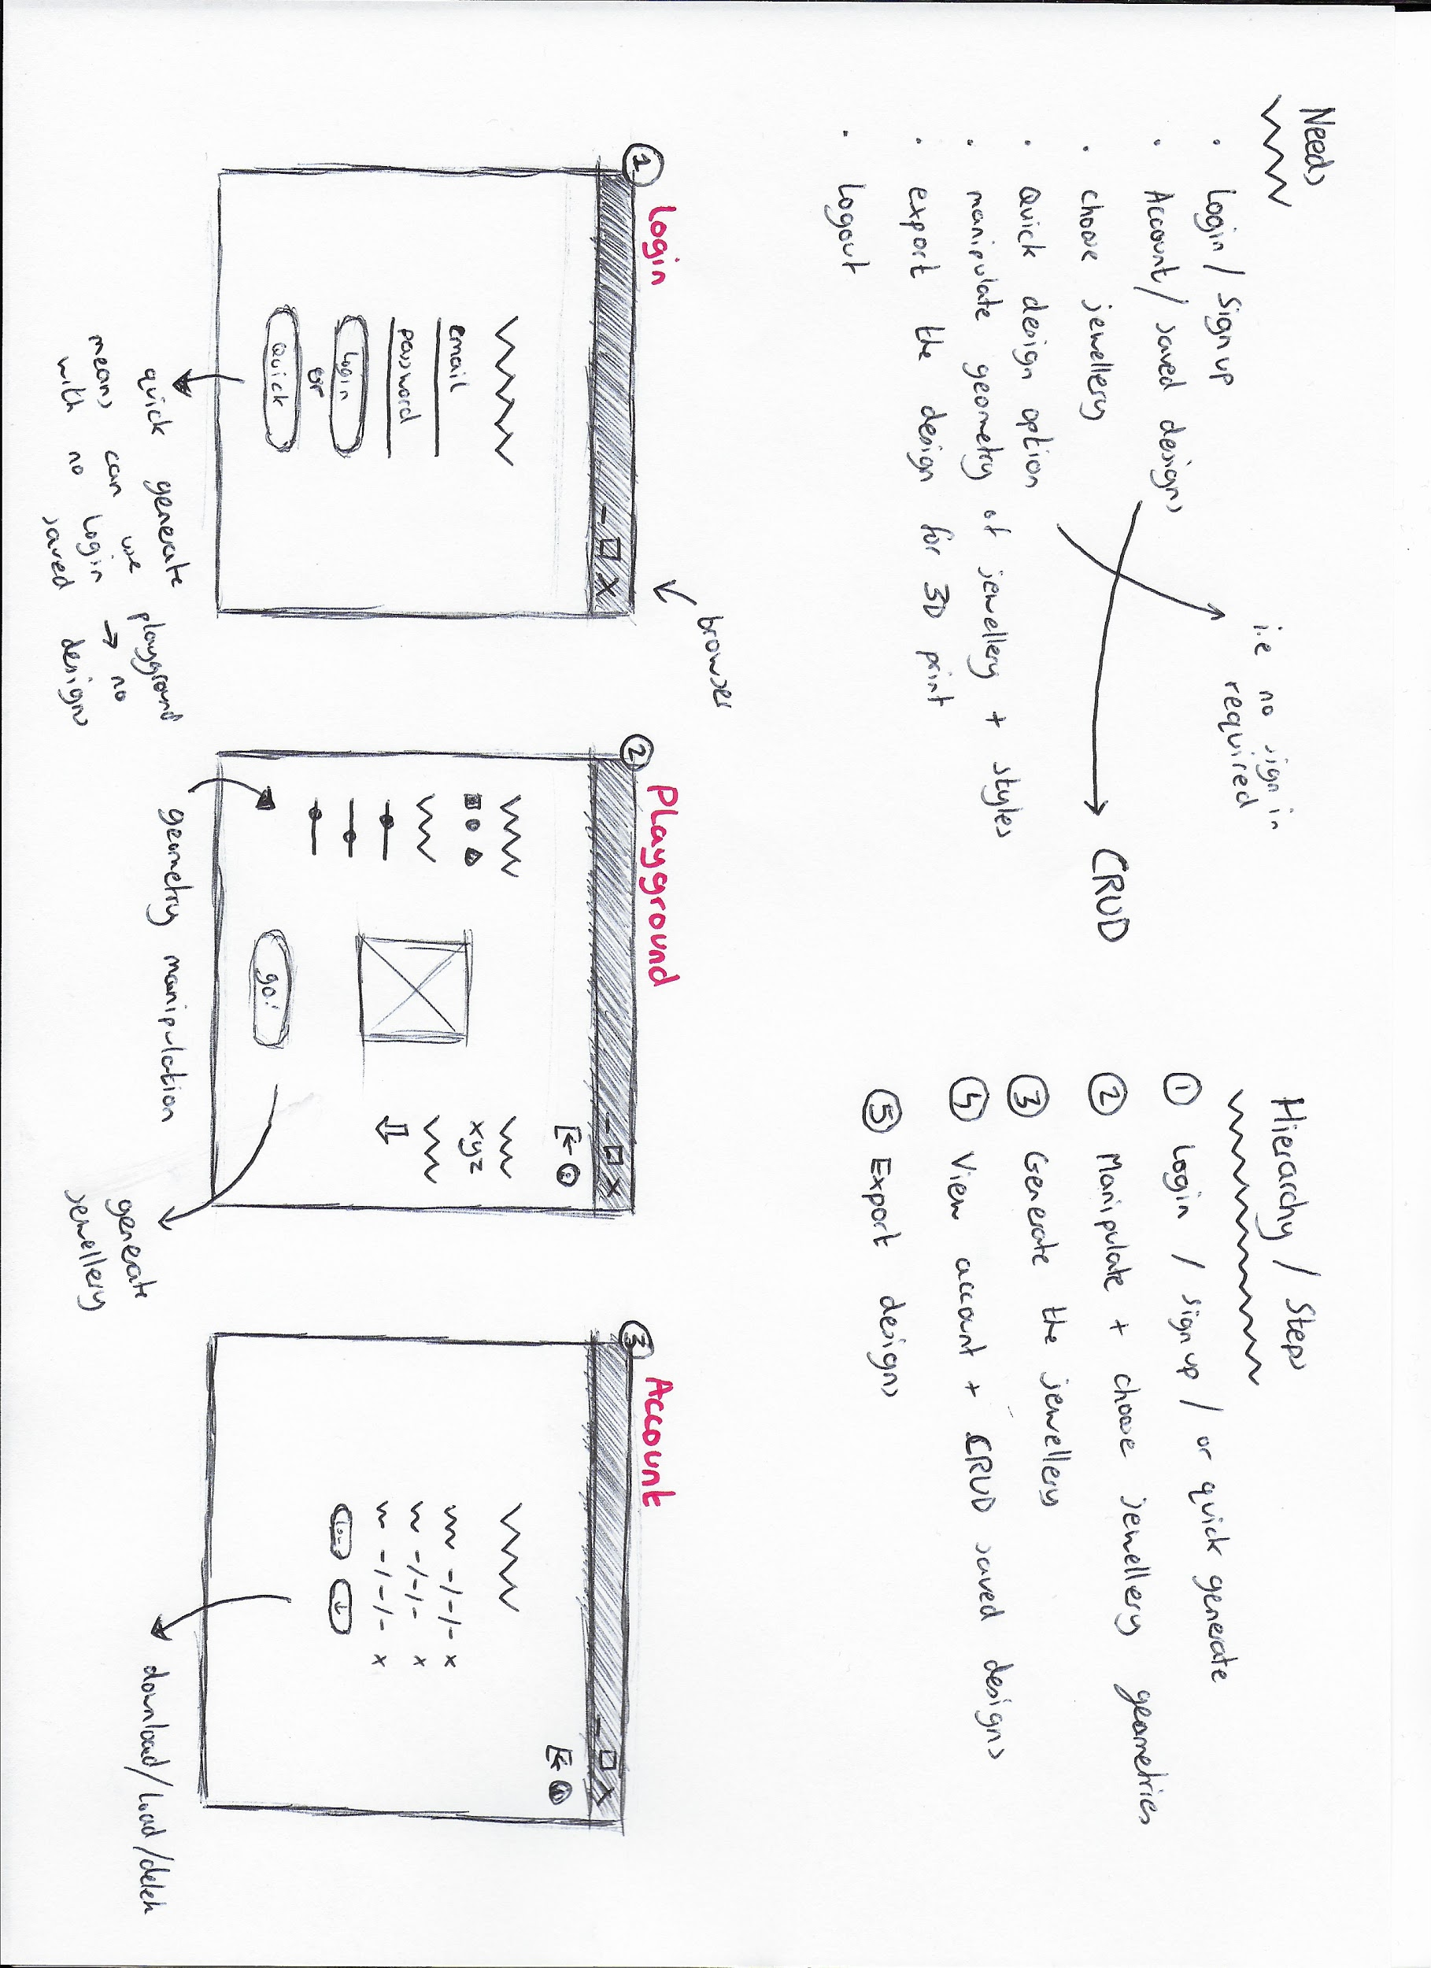

I determined that my application would be divided into three sections or components:

1. Log In / Sign up
2. Playground (Where the generative design functionality would take place)
3. Account (Where the user’s saved designs and CRUD functionality would lie)

### 

### Log In

The landing view of the application, this page will prompt users to enter their login details and sign in directing then to the playground page. If the user has no login, a link is provided to a sign up form for users to enter their relevant details, redirecting them to the playground page also.

*Quick Generate* is an alternative option to logging or signing in. This option will take the user directly to the application playground, however, there will be no option to view a user account and CRUD database of saved designs.

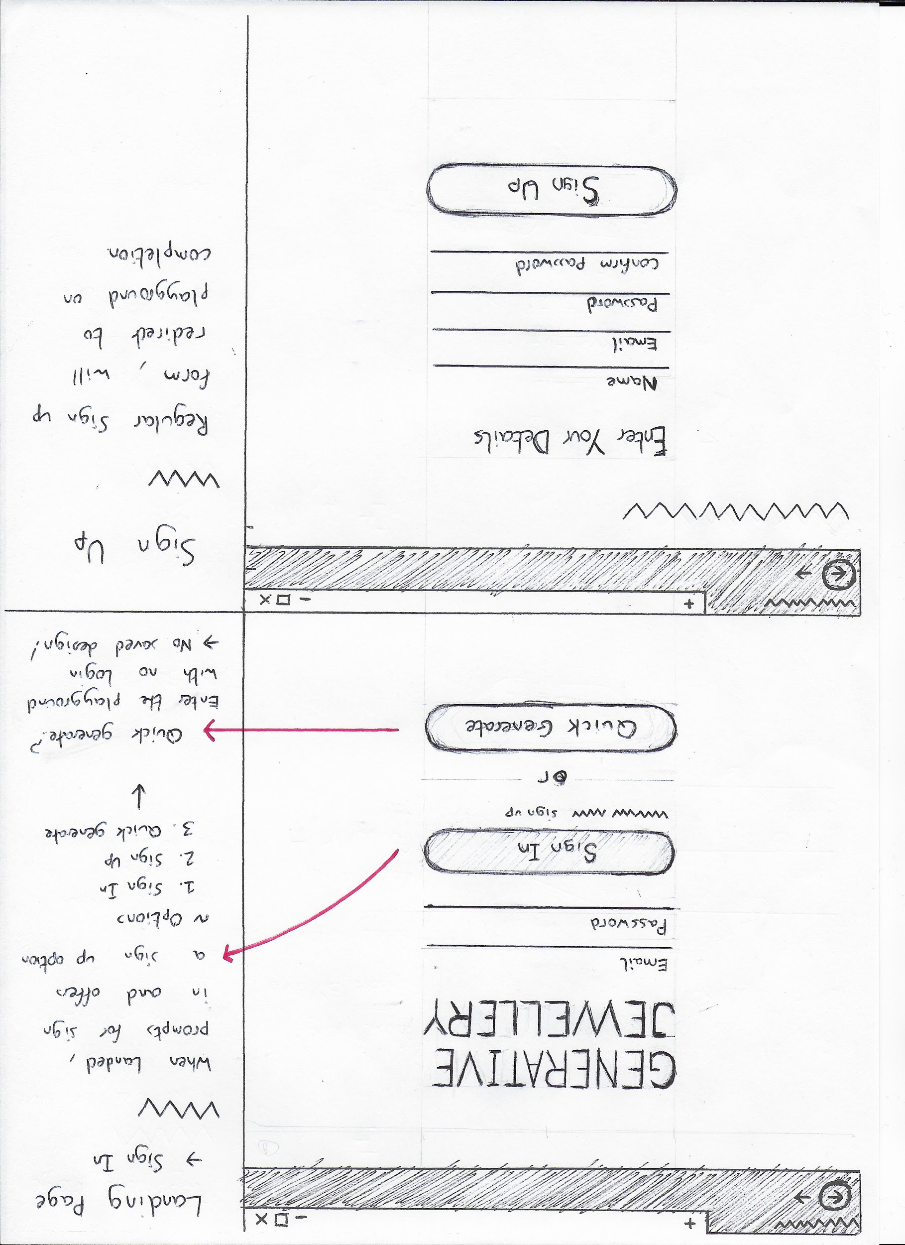

### Playground

The playground page is the backbone around which the application is centred; where most of the functionality of the derived from the design problem is implemented.

This page is where the user designs their jewellery. Here the user may choose their prefered piece of jewellery / starting shape and further modify its dimensions.

Furthermore, the user will specify their unique design patterns and constraints to be applied to the generative algorithm. These constraints are not yet clear as they will be deduced during the process of this project over time.

To that end it would be best to note that the algorithmic equations that will be applied to the geometry contain constants. The generative process will be determined by inserting the user’s own constants in place of the original.

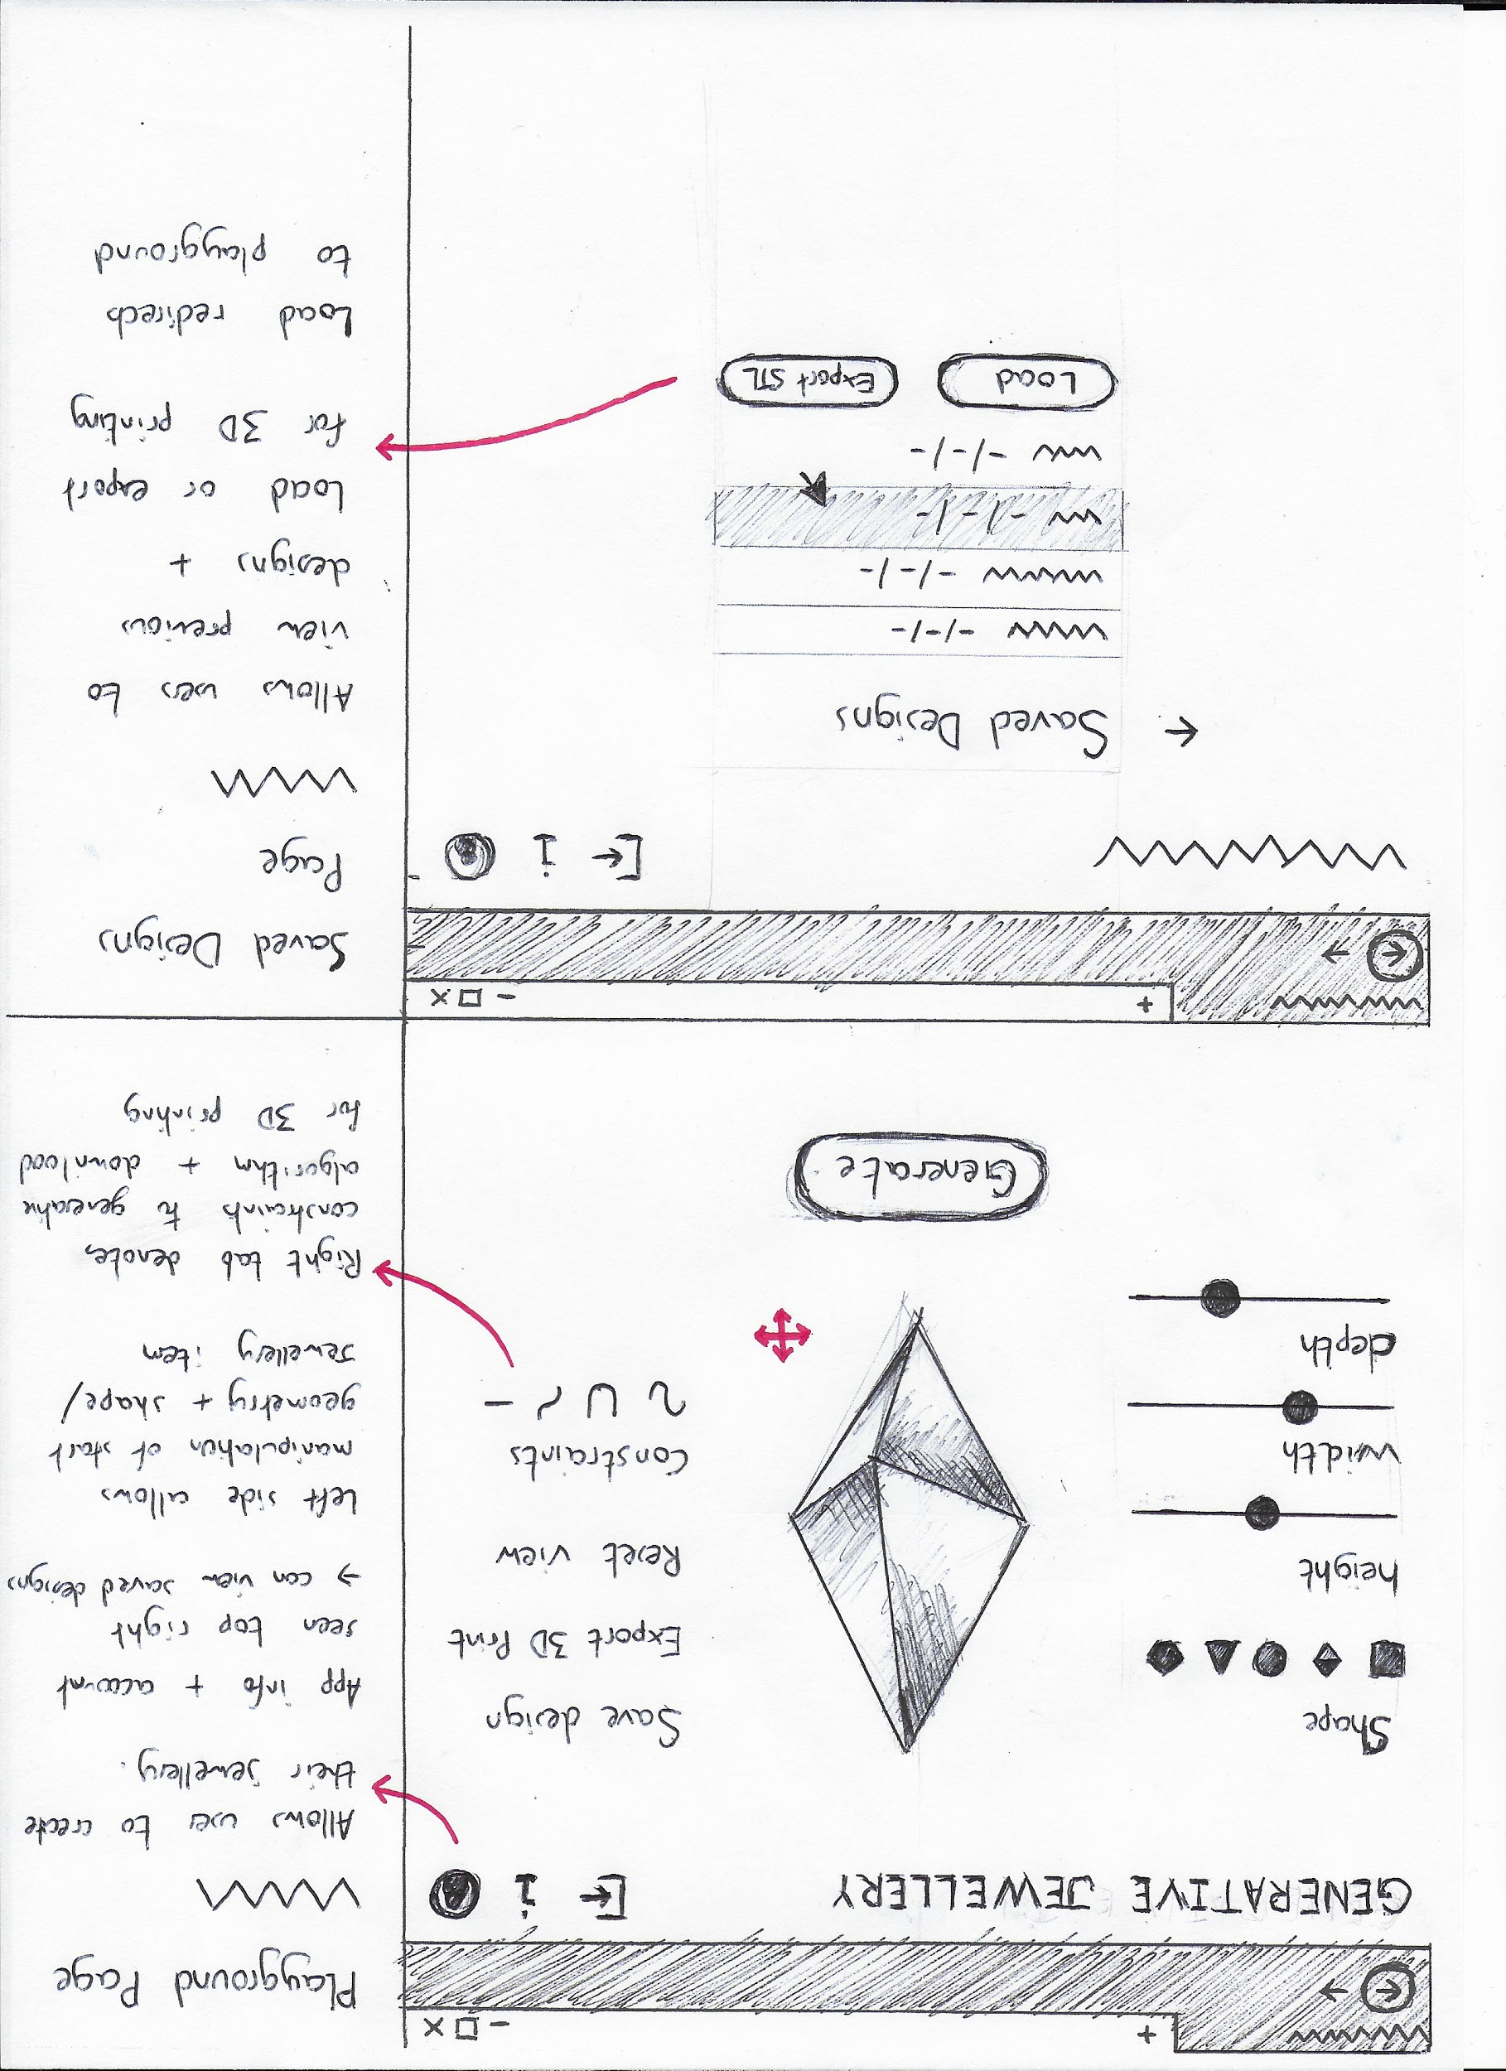

The user is also given the option to save and download their design in stereolithography (.STL) CAD format for use in 3D printing their jewellery.

Lastly, the user may view their account. This account will implement CRUD functionality in the realm of viewing the user’s saved designs, creating a new design, deleting a design and loading a previously saved design.

### Account

The account page is accessible through the playground page and is a traditional CRUD styled interface. The user will be presented with a list of their saved designs and is given the options to either create a new design, load a previously saved design, or delete an existing design.

Moreover, the user may be allowed to logout at any given time whether in the playground or account environments.

Again, the user also has the option to export any design in .STL format for 3D printing.



# 

# REQUIREMENTS ANALYSIS

## User Requirements

From research previously examined, it was determined that there would need to be two users:

1. Casual designer (guest user)
2. Registered designer (registered user)

Surmised, a user that would use the application once off for leisure, and another user that would frequently use the application, designing and printing numerous designs (i.e a crafts hobbyist).

Both users will have the same core requirements, however the guest user will *only* have the core requirement, whereas the registered user will be assigned additional requirements.

From the research findings the users (guest/registered user’s shared requirements) need to have the ability to:

1. Choose their shape / jewellery geometry
2. Manipulate their shape dimensions
3. Define unique generative constraints
4. Generate the jewellery
5. Export .STL file for 3D printing

The registered user then has the added requirements as follows:

1. Log in / sign up
2. View account / saved designs
3. Create, view, delete and edit designs
4. Logout

To visualise the choices available to a fresh, undefined user, a use case diagram was completed outlining the specific steps / flow of choices and the relationship between all.

See next page for use case diagram.

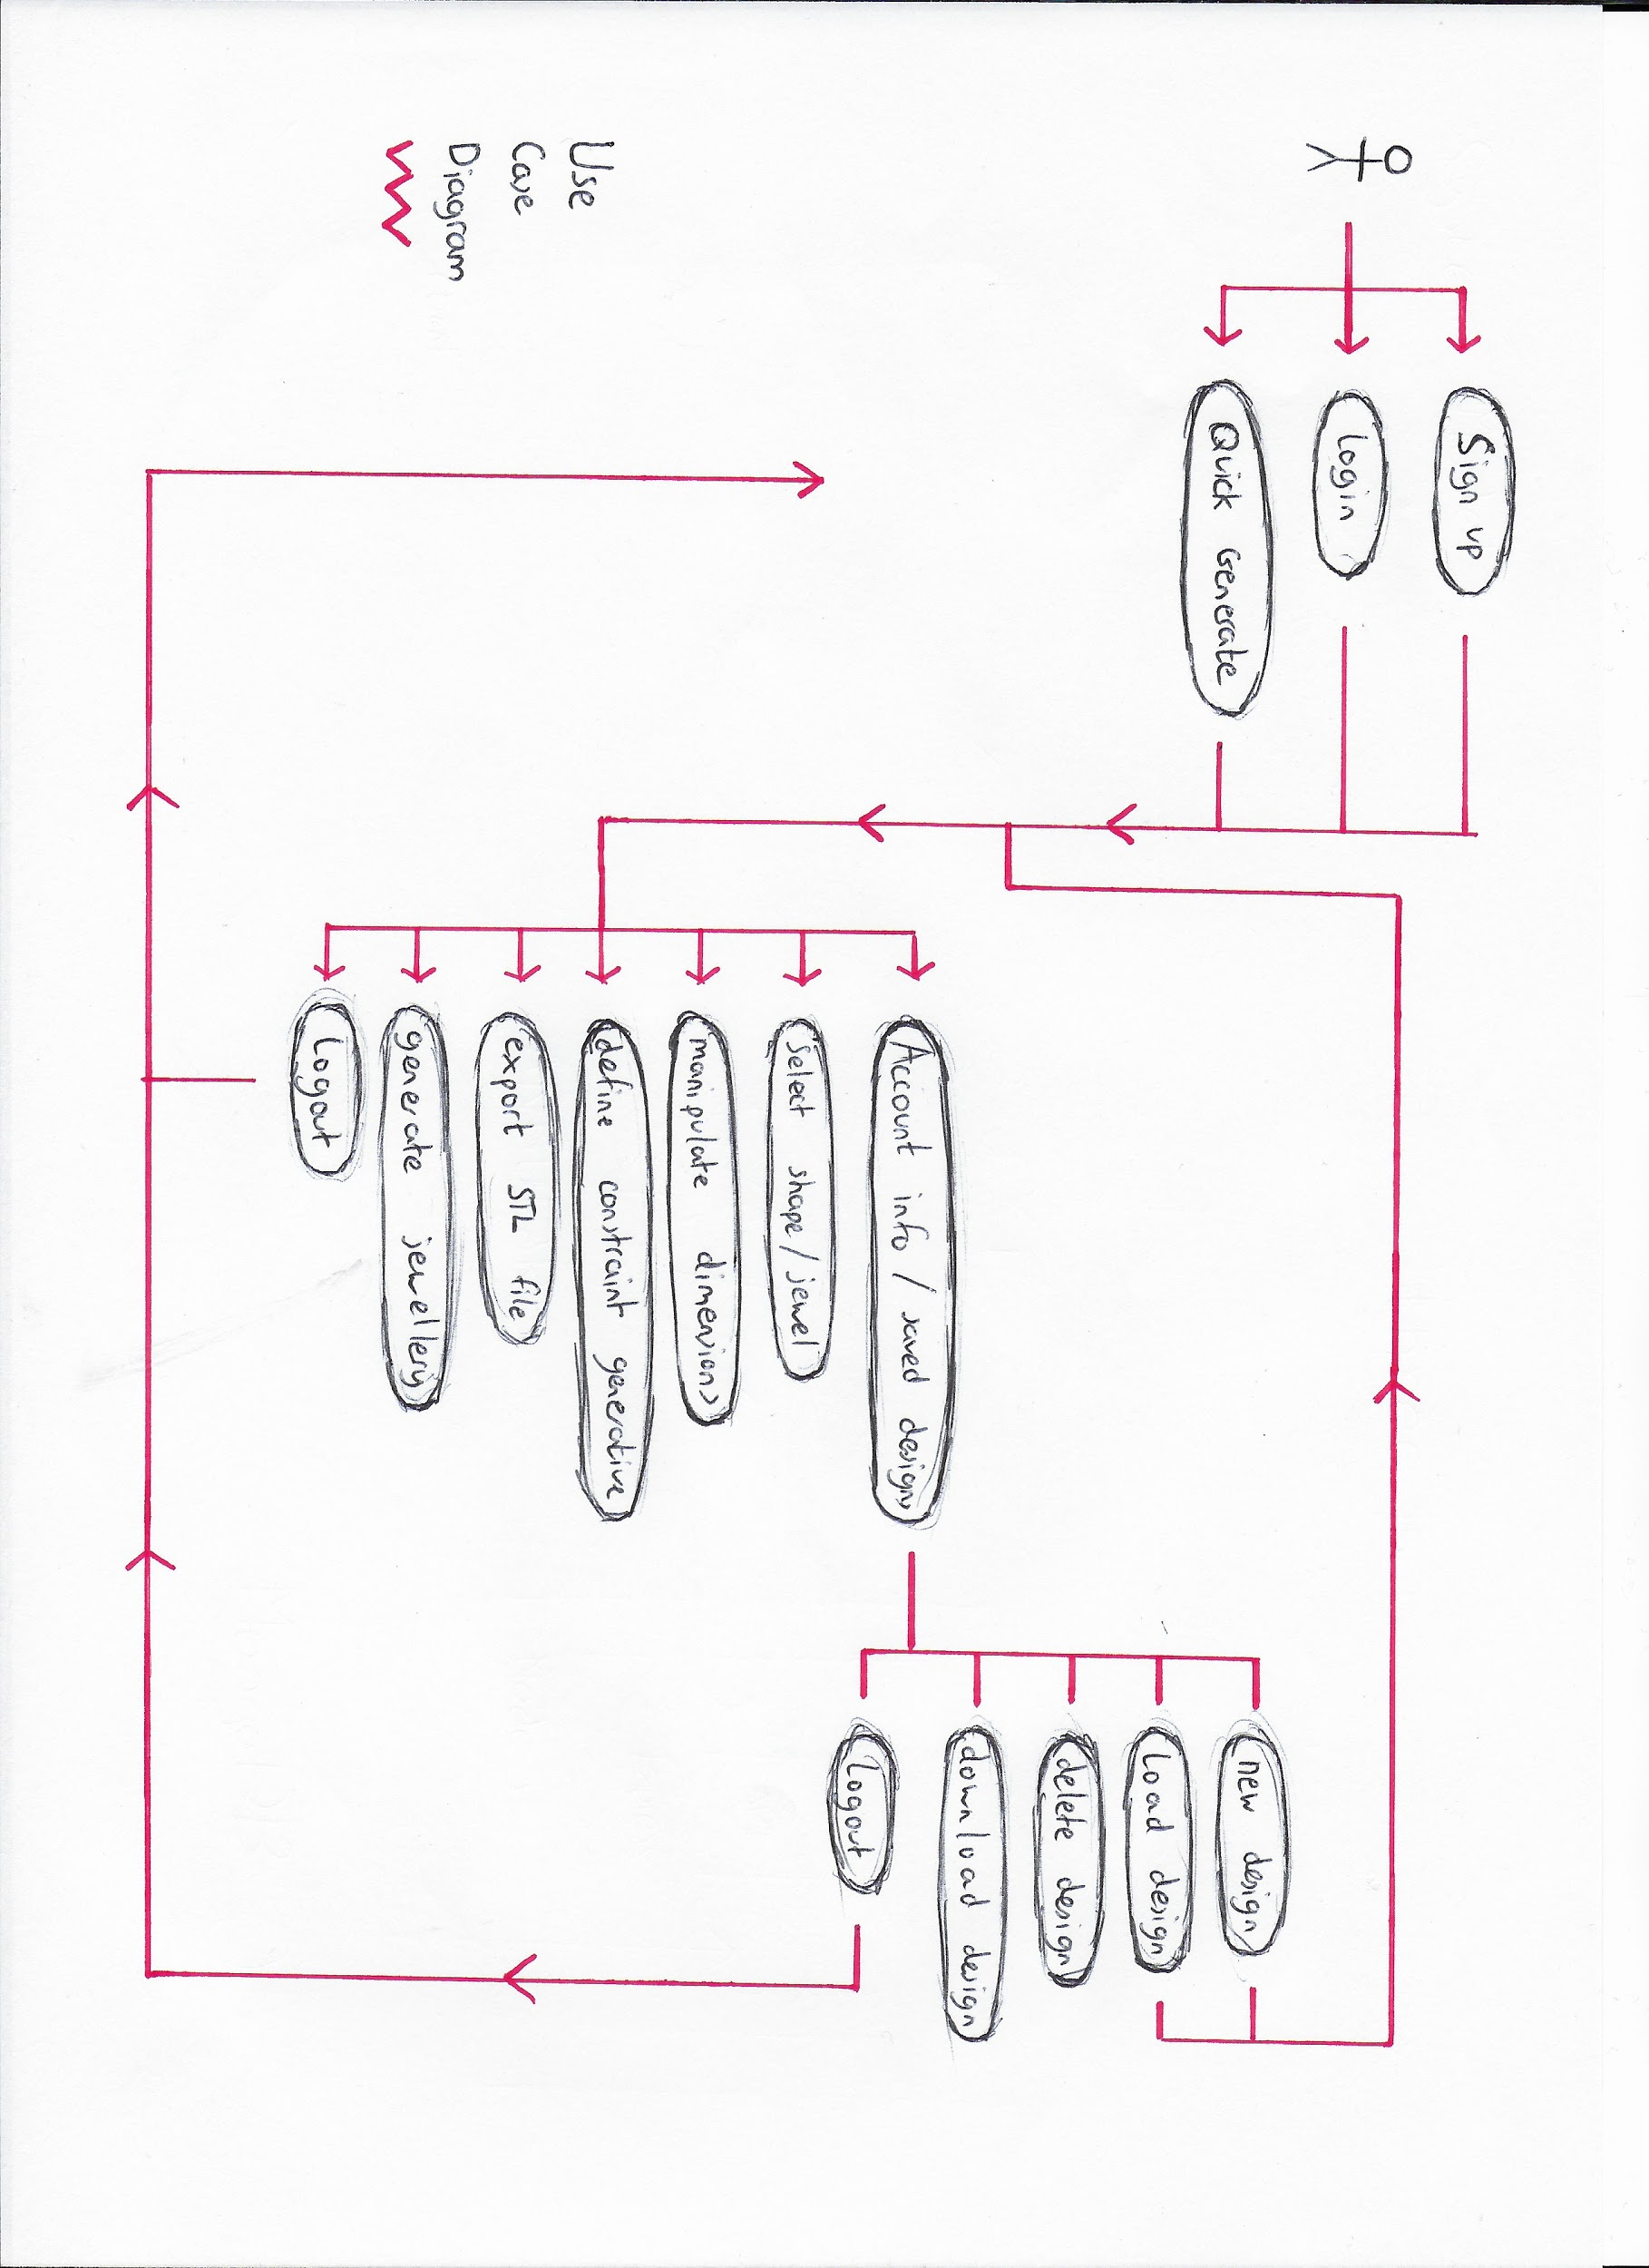

## 

## Functional Requirements

### Functionalities List

In defining functional requirements, input was taken from the user needs / hierarchy and prototype structure and layout. Functional requirements were then established in a page-by-page order derived from the prototypes.

*Log in:*

1. Login form
2. Sign in form
3. Quick generate button

*Playground:*

1. Orbit camera around 3D geometry
2. Select starting geometry (jewellery type)
3. Manipulate height, width, depth of geometry
4. Choose generative constraints
5. Generate the jewellery piece
6. Export .STL file for 3D printing

*If signed in:*

1. Save model
2. View Account
3. Logout

Account

1. View list of designs
2. Create a new design
3. Load a previously saved design
4. Edit design details
5. Delete a previously saved design
6. Export selected, saved design
7. Logout

### 

### Wireframe

Outlined in this first diagram are the relationships of movement between pages.

On the left we see the pages for login and sign up which themselves lead to the playground environment. The login page is the landing page, as discussed it prompts the user for account details or to sign up for the application. Alternatively a user may choose to act as a guest and progress directly to the playground environment, however with no save capabilities.

On the right we observe the playground environment whereby the core of the application is located. From here a logged in user may access their account or logout and return to the login landing page.

The user may choose to view their account. On the account page, the user may view their saved designed and interact with the database of designs implemented with CRUD functionality as discussed, for example loading a saved design back into the playground. The user may also download their designs for 3D printing or logout from here.

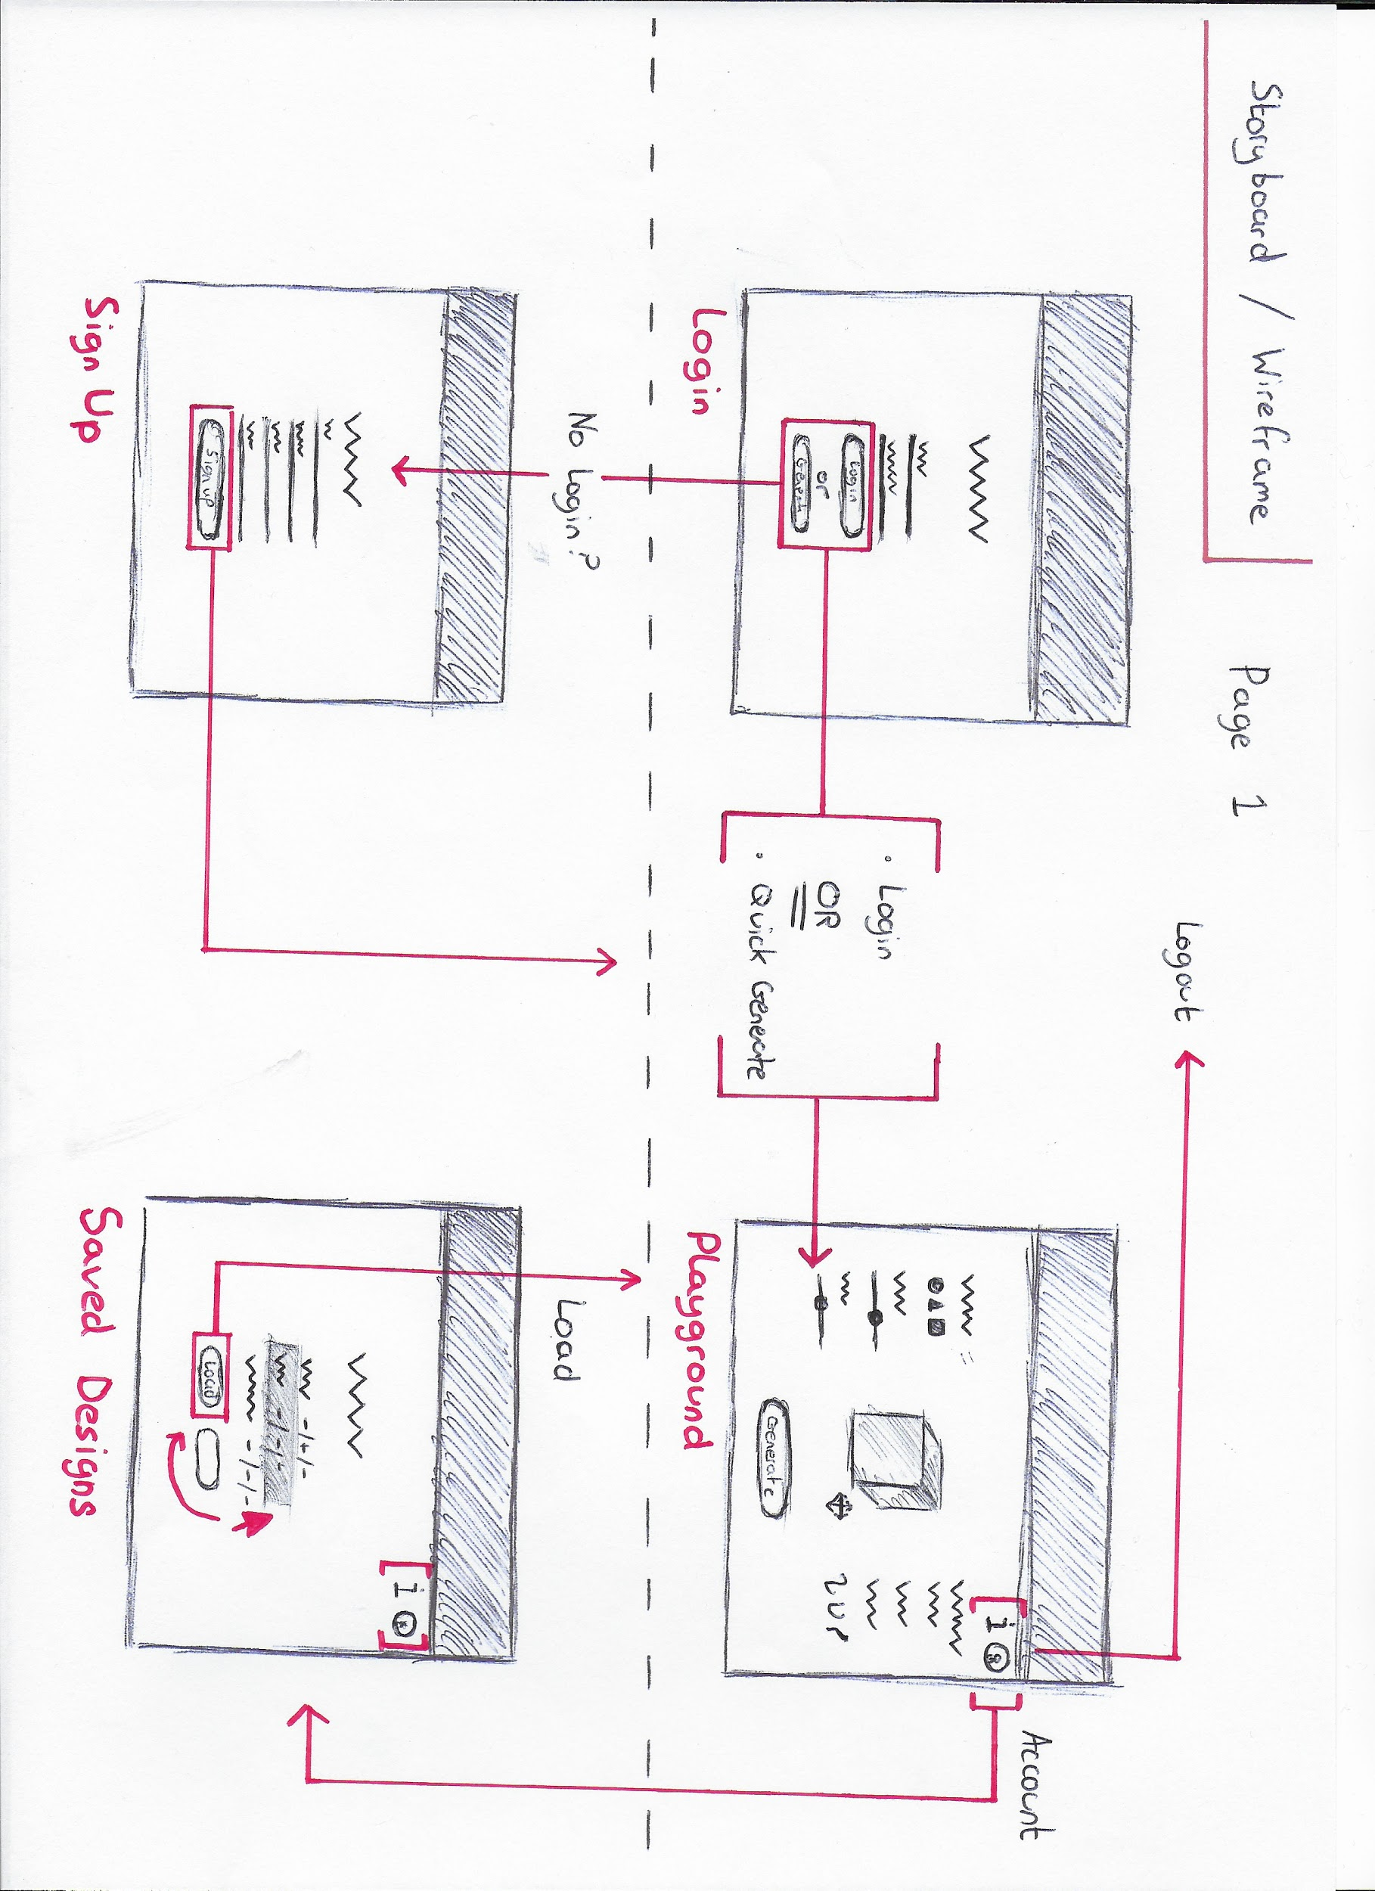

In this second diagram we scrutinise the playground page in a step-by-step fashion of executed user decisions, where the core of the application resides.

We begin with the playground geometry. The user is given options to predefine their jewellery shape by way of manipulating the dimensions of the primitive geometry. For example, selecting a cube, and shaping it’s height.

Moving on, the user may choose the generative constraints for the jewellery design, the parametres that will be applied to create the unique jewellery. The user may then choose to generate their new generative jewellery.

Once the design is finished generating and the user is satisfied, the user may choose to save their design to the database. Furthermore, the user may choose to download their designed jewellery’s geometries in a .STL format for 3D printing.

The user may iterate the generative process, starting again and also rotate the camera to view the finished design.

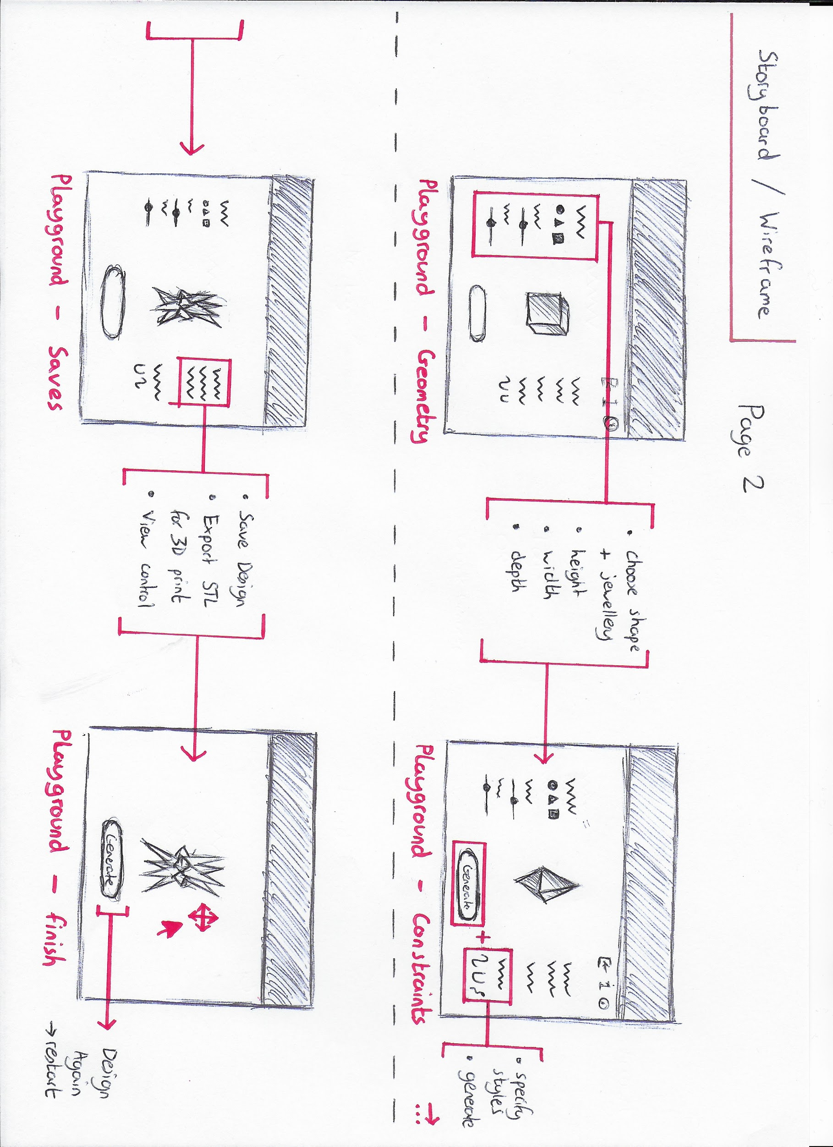

# 

# SYSTEMS MODEL

### Diagram

After determining the functionality requirements of the user, the next step was to define a model architecture through which the foundational structure of the application would be built around.

Five technologies were chosen to implement this architecture:

1. Three: a library for animated 3D computer graphics using JavaScript.
2. Angular: a development platform for building web applications using JavaScript.
3. Express: a web application server framework for Node using JavaScript.
4. Node: an execution environment for server-side applications using JavaScript.
5. MongoDB: a NoSQL database.
6. Catmull-Clark Subdivision Algorithm (Three): generative design process

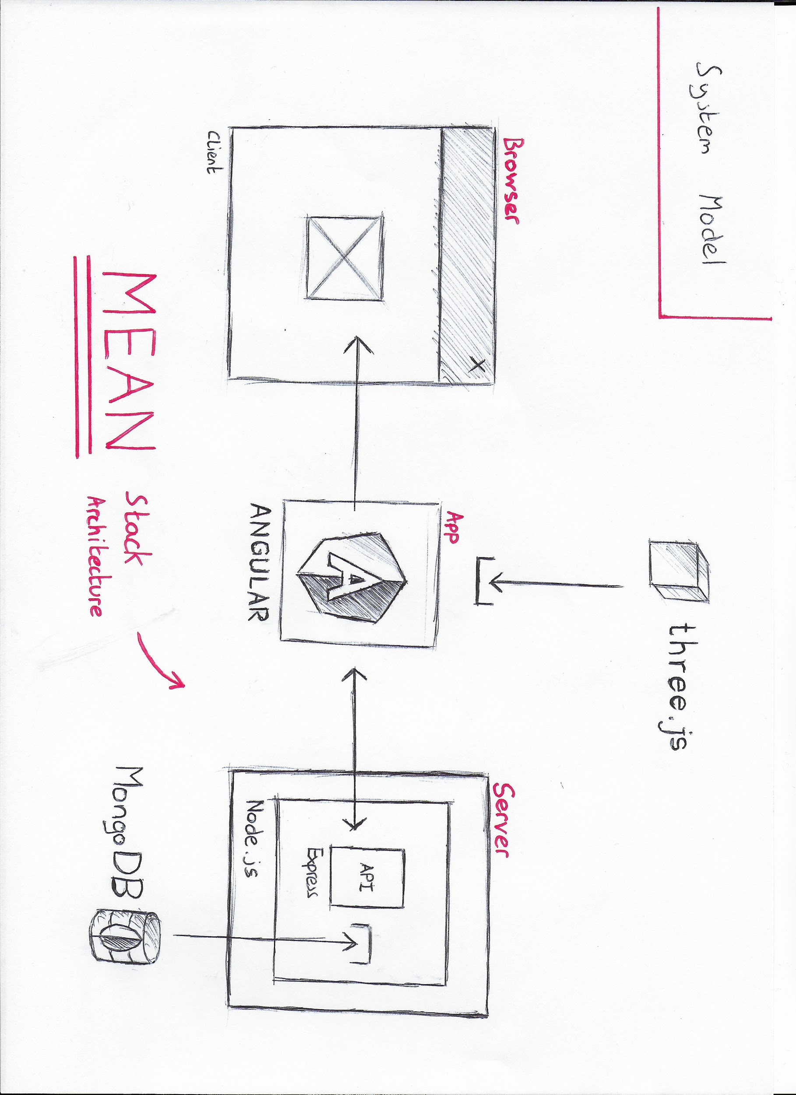

### 

### Three.js

Three is an open source JavaScript library and application programming interface(API) that utilises WebGL to create and display 3D computer graphics in a web browser.

Three.js is the obvious and most popular choice for rendering 3D content in a browser and has the best functionality for applying advanced queries and manipulations to complex geometries.

Therefore, due to the 3D nature and manipulative creative 3D requirements of this application, the three library is the most suitable option.

### MEAN Stack

The MEAN stack is a JavaScript focussed software stack that is used to build and deploy dynamic web applications. This stack is entirely open-source of which each technology of the acronym is supported by JavaScript. This means both client-side and server-side is written in one language.

The MEAN stack consists of MongoDB, Express, Angular and Node.

This stack includes the world’s leading NoSQL database that provides agility and scale using JSON. A minimal and flexible node web application framework. An expressive, responsive and easy to develop framework to extend your HTML. Lastly, a server-side platform built on Chrome’s JavaScript runtime for easily building fast, scalable network applications.

Rationale for development using the MEAN stack:

1. Entirely in JavaScript.
2. Excellent for single page applications.
3. Open-source support.
4. Utilises JSON, perfect for handling large 3D geometry files.

Considering these factors, the MEAN stack is a favourable option for this project.

### 

### Catmull-Clark Subdivision Algorithm

In this application there is defined a point where the user may *apply a constraint* and *generate* a design. This aspect of the application is the main research topic of this project.

A subdivision is a three step algorithm whereby the points, edges and faces of a geometry are found using maths and are used in an equation to divide a face of a 3D geometry in a number of new faces defined by the number of vertices for that face. For example, a cube has a square face, a square face has four corners, thus four vertices. When subdivided, the one face becomes four new smaller faces in place of that original face.

The specific subdivision that will be used in this project is the Catmull-Clark algorithm, developed by two leading figures currently working at Pixar studios.

The algorithm in detail consists of three steps, which are iterated through to produce a smoother surface for a geometry. The technique is used in animation to smooth, for example, the skin surface of Woody from Toy Story.

What is being done fundamentally is calculating and finding all new vertices and replacing the original vertices with them.

Given a mesh in 3D space (imagine the face of a cube) find :

1. ***Face Points*** : the average of all vertex points defining a face.
2. ***Edge Points*** : the average of two adjoining face’s Face Points and their two shared vertex points
3. ***New Vertex Points*** : the average of all Face Points surrounding the current vertex we are redefining + the average of all Edge Points plus some constant multiplied by the current vertex.

Define the new vertex points found for the entire geometry in place of the originals(the subdivision). Then re-iterate through the algorithm.

The generative design application of this algorithm on a geometry comes from the idea of origami. While we divide the surfaces of a geometry, a 3D form in space, we can fold the volume of the forms in an infinite number of different ways using maths. We can add in our own specific constants to the algorithm and create odd, complex forms.

To implement this algorithm, a data structure is needed. In our case there is one specifically for subdivisions named *Half-Edge*. This algorithm is built into Three and is a pointer system whereby each face edge (shared with another face) has two pointers either side of it that point to one another. Thes pointers, point to the face they belong to, the vertex they belong to and the next edge pointer clockwise to them on their face. This system is used to navigate over all vertices.

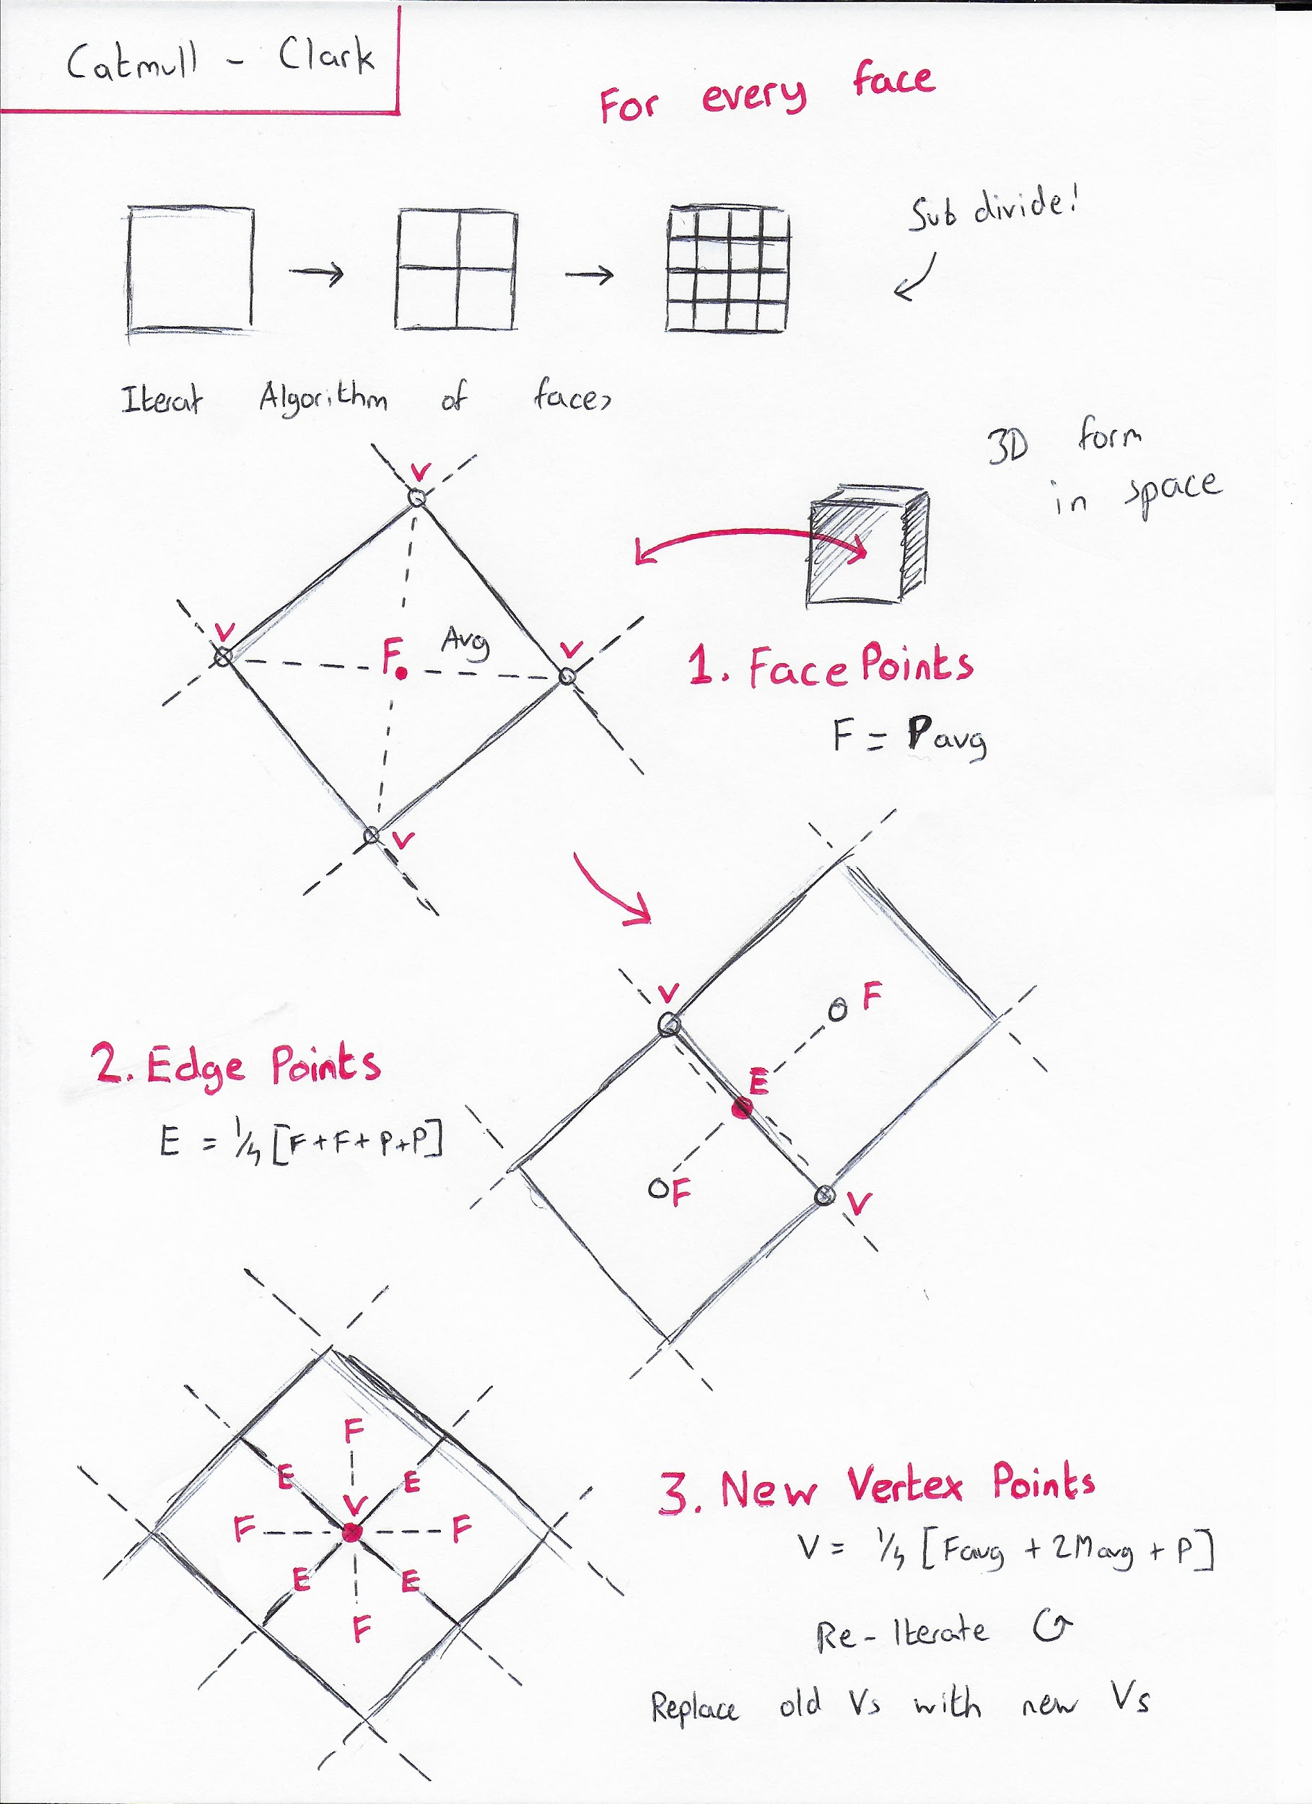

# RISK ANALYSIS (FEASIBILITY STUDY)

### MEAN Stack

With regards to this project there is a need for a web application framework and database functionality, this is the case without a doubt. However, the risk involved is in choosing the correct platform that will provide the optimal output.

This year during the course of Dr. Andrew Errity’s course, the class will be learning the MEAN stack and its components. Furthermore, the stack is entirely in JavaScript, a language we in the course are very proficient with, so too with Node. The stack is again, open source, with lots of support and tutorials.

With regards to application frameworks, the course has given us proficient knowledge in the theoretical and practical implementation of such a technology.

With all this said, the MEAN stack is still a new topic and there is a risk of required learning eating up a lot of the limited project development time.

### Generative Design Algorithms

The generative design and 3D portion of this application, carried out in Three library as mentioned provides an element of unknown to the project.

To generate the jewellery, we must apply the subdivision algorithm and also manipulate it’s constraints, however to do this there requires a data structure known as *half-edge* used to navigate over the geometries.

This data structure is built into Three and has lots of notation but few examples. This does not present a problem at first glance, but once one understands the data structure as mentioned previously, and then attempts to apply it, it may present a problem. This is a potential problem that may eat into the development time frame.

Furthermore, defining the generative constraints of the subdivision algorithm may take time also as it will involve a lot of trial and error to observe the different complex forms to be generated.

### 3D Printing

The entire point of this application is jewellery and it’s creation. As a hopeful *icing on the cake,* if completed to the planned standard, there is a hope that a user may save a design in a certain file format for 3D printing and actually produce some 3D printed pieces, but it is not of paramount importance.

# PROJECT MANAGEMENT

From experience and results, it has been determined that this project’s management in time keeping, documentation and file hosting will be carried out using the Trello kanban system and the GitHub repository environment.

The kanban system from Trello provides seamless management and organisation of tasks, list items, notes and also allows for third party application links for live documents, e.g Google Drive.

Then on the opposite hand, GitHub is a free file storage and lightweight management environment that support multiple user inputs and keeps track of project contributions, ideal for long project time frames.

# 

# BIBLIOGRAPHY

[2] Pier 9 Technology Centre. Project Dreamcatcher with Erin Bradner and Michael Bergin. (2015). from <https://www.youtube.com/watch?v=jvN5AVZW8r8&feature=youtu.be>

[3] Mode Lab. Parametric Design Fundamentals. (2017). from <https://www.youtube.com/playlist?list=PLGV167zE8gnUF2JbcgpfRDQ-FYaYXH5se>

[5] Maurice Conti. The Incredible Inventions of Intuitive AI. (2016). from <https://www.ted.com/talks/maurice_conti_the_incredible_inventions_of_intuitive_ai>

[6] Autodesk Education. Generative Design: co-creating with AI. (2017). from <https://www.youtube.com/watch?v=ws7XS7rVdEI>

[7] Yury Petrov. Algorithm-Driven Design. (2017). from <https://algorithms.design/>

[8] Alexander Miller. Recreating Vintage Computer Art with Processing. (2015). from <https://www.youtube.com/watch?v=LaarVR1AOvs&t=66s>

[9] Michael Hansmeyer. Building unimaginable shapes. (2012). From <https://www.youtube.com/watch?v=dsMCVMVTdn0>

[11] Autodesk Research. Project Dreamcatcher. (2017). From <https://autodeskresearch.com/projects/dreamcatcher>

[12] Geometric Modeling Lectures. UC Davis (2015). From <http://graphics.cs.ucdavis.edu/~joy/GeometricModelingLectures/Unit-9/Unit9.html>

[13] Computer Graphics. UC Davis. Youtube. (2015). From <https://www.youtube.com/playlist?list=PL_w_qWAQZtAZhtzPI5pkAtcUVgmzdAP8g>

[14] The Half Edge Data Structure. Max McGuire. (2000). From <http://www.flipcode.com/archives/The_Half-Edge_Data_Structure.shtml>